What is Java?

Java is Programing Language.

* Java is language and platform as well.

What is Machine Language?

* Machine Language is defined in binary firm 0 and 1.

What is Assembly Language?

* Assembly language is defined in Alphanumeric form STAR, ADD, SUB

What is complier?

* Complier directly converts the source code into machine Language.
* Translate high language p

What is Assembler?

* Assembler converts the input or source code into the complier and then interpret to machine language.

What is High level Language?

* High Level programing language comes with built in complier and interpreter.
* It is Machine Independent.

What is Linker?

Linkers works with modules. It links with code modules for faster execution.

What is interpreter?

Operating System + Processer = Platform.

**Software Code Compilation & Execution process**

Editor: Editor where we can write the source code e.g Eclipse, notepad

Complier: It converts the high programing Language into native machine language.

Linker: It combines different program files and converts them into one file program

Loader: it load the files from secondary storage devices from flash or CD into RAM for execution. Everything happens automatically.

Execution: Actual execution of the code is carried by operating system and Processors.

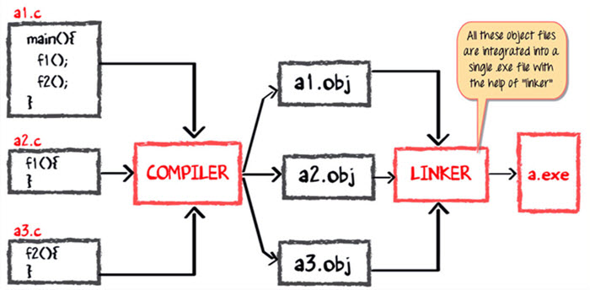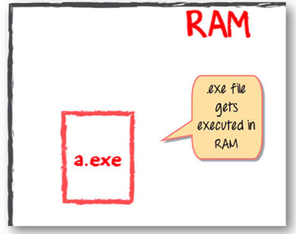

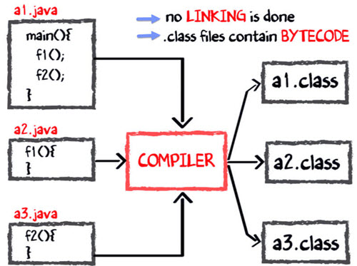

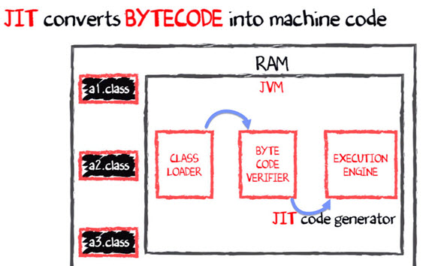

References:

<https://www.guru99.com/java-virtual-machine-jvm.html> (for JVM)